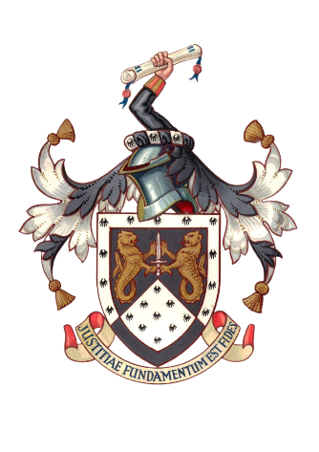Annual Law Dinner - Friday 10th October 2025
Newcastle upon Tyne Law Society

c/o Burnetts Solicitors,
7th Floor, 1 Citygate, Gallowgate, Newcastle upon Tyne NE1 4JE

Tel: 0191 232 5654
Email: mail@newcastlelawsociety.co.uk
Website: www.newcastlelawsociety.co.uk

On behalf of the President Paul Brown, we have pleasure in inviting you to this year’s Law Dinner which will take place on Friday 10th October 2025 at 7.00pm at The Grand Hotel Gosforth Park, High Gosforth Park, Newcastle upon Tyne NE3 5HN. Dress: Black Tie. We very much hope you will be able to join us.

Single ticket price £75, Newly Qualified £70, Retired members £60, Trainee/Student £45. Bookings received before the 22nd of August will receive a 10% discount. Tables are available for 6 – 12 people. Table for 6 @ £440, table for 8 @ £560, table for 10 @ £700 & table for 12 @£840. We offer mixed tables for smaller firms.
Names | Company | Tickets (please state type)
Payment methods:-
By cheque made payable to the Newcastle Law Society to be posted to the above address.
By bank transfer, our bank details are:- Sort code: 30-93-71, Account No: 00969309, Newcastle upon Tyne Law Society Please put ref: (AD then your surname or company)

